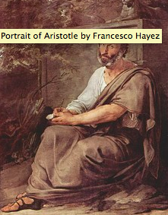
Aristotle’s Tragic Hero

Tragedy:
a devastating event, or string of events, that cause the downfall of a protagonist.

In Poetics, Aristotle sketched out the template from which he believed true tragedy was made. He also suggested that there are some rules to which all tragic heroes must conform.

Aristotle’s definition of tragedy:

_____________________________________________________________________________________________________________________________________________________________________________________________________________________________________________________________________________________________________________________________________________________________________________________________________________________________________________________________

Katharsis _________________________________________________________________________________

Mimesis __________________________________________________________________________________
 | The tragic hero or heroine must evoke pity or fear in an audience. In order to do this effectively, the tragic protagonist must fit a particular character type. | He, or she, must be a person to whom we can relate - therefore, a tragic hero cannot be unrealistically virtuous. | He or she cannot be evil either, otherwise we will not feel empathy for their plight. | A tragic hero must be morally blameless for his misfortune (this is interpreted rather loosely by some playwrights, as you’ll | Tragic protagonists meet with a downfall and, often, death, which is precipitated by a fatal flaw (hamartia) that causes him or her to perpetrate some unintended, although usually pretty horrific, act.
Othello
Pygmalion
Streetcar
Six Degrees
Every tragedy must have six parts:

1.PLOT

UNITY OF ACTION:

In his book Technique of the Drama (1863), The German critic Gustav Freytag proposed a method of analyzing plots derived from Aristotle's concept of unity of action that came to be known as Freytag's Triangle or Freytag's Pyramid.

Aristotle calls the cause-and-effect chain leading from the incentive moment to the climax the “tying up” (desis), in modern terminology the complication. He therefore terms the more rapid cause-and-effect chain from the climax to the resolution the “unravelling” (lusis), in modern terminology the dénouement (context).
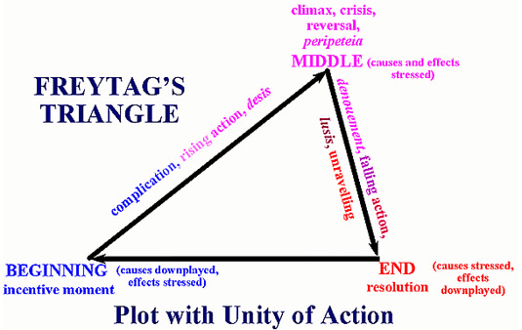
 | The plot must have a beginning, middle and end | The beginning (incentive moment), must start the cause-and-effect chain but not be dependent on anything outside the compass of the play (i.e., its causes are downplayed but its effects are stressed). | The middle (climax) must be caused by earlier incidents and itself cause the incidents that follow it (i.e., its causes and effects are stressed). | The end (resolution) must be caused by the preceding events but not lead to other incidents outside the compass of the play (i.e., its causes are stressed but its effects downplayed); the end should therefore solve or resolve the problem created during the incentive moment
Othello

Pygmalion
Streetcar
Six Degrees

The plot must be “of a certain magnitude,” both quantitatively (length, complexity) and qualitatively (“seriousness” and universal significance). | Plots should not be too brief; the more incidents and themes that the playwright can bring together in an organic unity, the greater the artistic value and richness of the play. | Also, the more universal and significant the meaning of the play, the more the playwright can catch and hold the emotions of the audience, the better the play will be | Simple or complex plot?  Catastrophe?  Perepetia?  Anagnorisis?
Othello

Pygmalion

Streetcar

Six Degrees

Perepetia
____________________________________________________________________________________________________________________________________________________________________________________________________________________________________________________________________________________________________________________________________________________________________

Anagnorisis

____________________________________________________________________________________________________________________________________________________________________________________________________________________________________________________________________________________________________________________________________________________________________

Catastrophe
____________________________________________________________________________________________________________________________________________________________________________________________________________________________________________________________________________________________________________________________________________________________________

