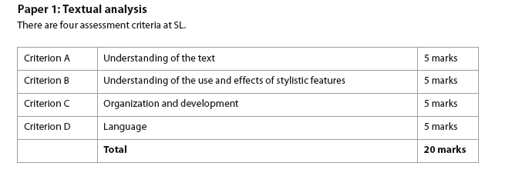
PAPER 1 STANDARD LEVEL
TOTAL MARKS
A | B | C | D

Criterion A: Understanding of Text

- To what extent does the analysis show an understanding of the text, its type and purpose, as well as its possible contexts (for example, cultural, temporal, relation to audience)?
- Are the comments supported by references to the text?

Marks | Level Descriptor
0 | The work does not reach a standard described by the descriptors
1 | Little understanding of the text and context; comments are not supported by references to the text.
2 | Some understanding of the text and context; comments are sometimes supported by references to the text.
3 | Adequate understanding of the text and context; comments are mostly supported by references to the text.
4 | Good understanding of the text and context; comments are consistently supported by references to the text.
5 | Very good understanding of the text and context; perceptive comments are supported by consistently well-chosen references to the text.

Criterion B: Understanding of the use and effects of stylistic features

- To what extent does the analysis show awareness of how the stylistic features of the text, such as language, structure, tone, technique and style, are used to construct meaning?

- To what extent does the analysis show understanding of the effects of stylistic features (including the features of visual texts) on the reader?

Marks | Level Descriptor
0 | The work does not reach a standard described by the descriptors
1 | Little awareness or understanding of the use of stylistic devices
2 | Some awareness and understanding of the use of stylistic devices
3 | Adequate awareness of the use of stylistic devices, with some understanding of their effects
4 | Good awareness of the use of stylistic devices, with adequate understanding of their effects
5 | Very good awareness of the use of stylistic devices, with good understanding of their effects
Criterion C: Organisation and development

- How well organized and coherent is the analysis?
- How well is the argument of the response developed?

Marks | Level Descriptor
0 | The work does not reach a standard described by the descriptors
1 | Little organization is apparent, with reliance on paraphrase and summary rather than analysis
2 | Some organization is apparent; the analysis has some coherence but may contain elements of paraphrase, summary and simple explanation. There is little development of the argument.
3 | Adequately organized in a generally coherent manner. There is some development of the argument.
4 | Well organized and mostly coherent analysis. The argument is adequately developed.
5 | Effectively organized and coherent analysis. The argument is well developed.

Criterion D: Language

- How clear, varied and accurate is the language?
- How appropriate is the choice of register, style and terminology? (‘Register’ refers, in this context, to the student’s use of elements such as vocabulary, tone, sentence structure and terminology appropriate to the task.)

Marks | Level Descriptor
0 | The work does not reach a standard described by the descriptors
1 | Language is rarely clear and appropriate; there are many errors in grammar, vocabulary and sentence construction and little sense of register and style
2 | Language is sometimes clear and carefully chosen; grammar, vocabulary and sentence construction are fairly accurate, although errors and inconsistencies are apparent; the register and style are to some extent appropriate to the task.
3 | Language is clear and carefully chosen with an adequate degree of accuracy in grammar, vocabulary and sentence construction despite some lapses; register and style are mostly appropriate to the task.
4 | Language is clear and carefully chosen with a good degree of accuracy in grammar, vocabulary and sentence construction; register and style are consistently appropriate to the task.
5 | Language is very clear, effective, carefully chosen and precise, with a high degree of accuracy in grammar, vocabulary and sentence construction; register and style are effective and appropriate to the task.

